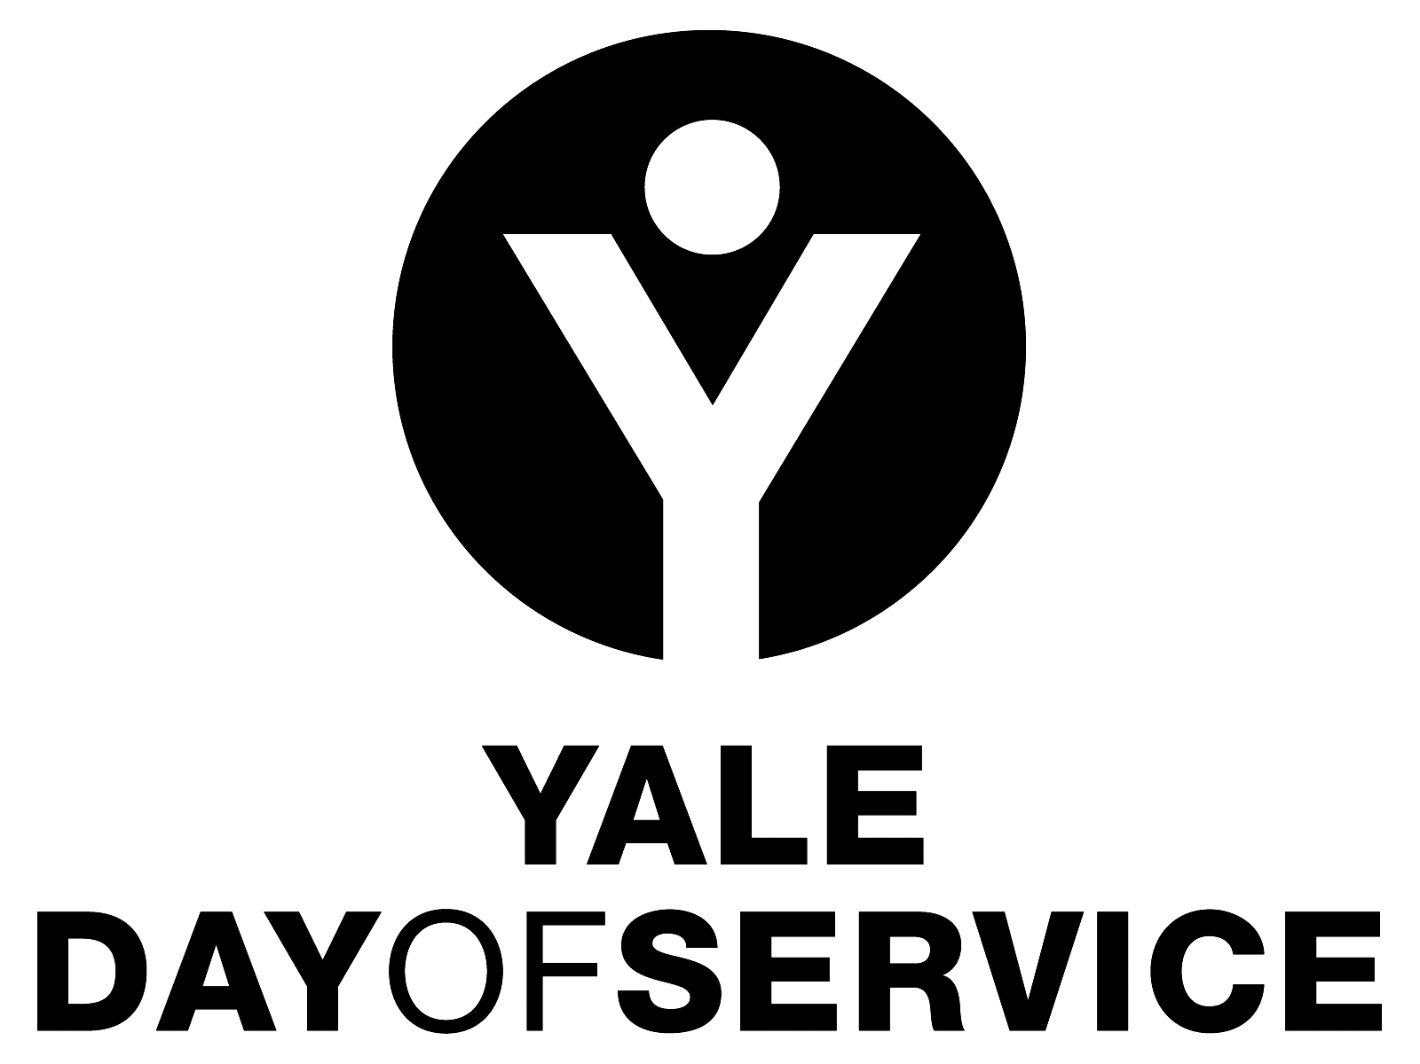

Yale Day of Service
PROJECT COORDINATOR TASKS & TIMELINE

Thank you for your interest in being part of the Yale Day of Service! The success of your Yale Day of Service program—whether in-person or virtual—will depend on many factors. Having a designated volunteer(s) willing to take on a leadership role is perhaps the most critical. Following is a general overview of the tasks involved in managing the Yale Day of Service in your physical or virtual community.

- INVESTIGATE POSSIBLE SERVICE PROJECTS.
Talk to members of Yale alumni groups in your network – local region, shared interest, Yale College Class, graduate/professional organizations, or online community—to solicit ideas for nonprofits that might be good fit for a Yale Day of Service activity. Working with a committee or other group of interested alumni as you plan the Day of Service may be helpful when considering the options for service sites. Engaging committee members also helps create a broader sense of ownership for the activities of the day.
Your regional director also has information on the kinds of projects you might think about. Items to consider:

  - Location. Is the site easy to get to; will volunteers need a car or can they use public transportation; will you be able to recruit enough volunteers to complete the project?

  - Age Appropriateness. There is great interest in family friendly sites so ask about age restrictions and other limitations.

  - Service Population. Who will benefit from the service project.

  - Estimated Enrollment. Approximately how many volunteers do you expect to participate.

  - Multiple Sites. If you are considering more than one site for your group, think about including a variety of settings that can accommodate people interested in distanced participation, outdoor-only, virtual, and/or non-manual labor oriented activities. If you are registering multiple sites, we strongly suggest that you have a Yale volunteer to serve as the coordinator or host for each site.

  - Building Community. Look at sites that accept a minimum of 5 volunteers to promote the opportunity for Yalies to build community with each other.

  - Alternate Dates. While we encourage scheduling Yale Day of Service activities for the second Saturday in May, please know that hosting Yale Day of Service activities on other dates due to scheduling conflicts or religious considerations is just fine.

- SELECTING AND WORKING WITH SERVICE ORGANIZATIONS.
Once you and/or the committee have determined a list of potential sites, contact the sites to inquire about needed volunteers, project details, and date availability. Select the project(s) that best match the criteria determined above and determine the project details including: description, time, location, volunteer capacity, and suggested ages of participants.

Ask the director or staff contact of the service agency to supply the following details for Yale Day of Service volunteers:
  - Project Details. What is the project, who is it benefitting, what are the tasks, and how can volunteers be most helpful?
  - Project Scope/Commitment. What is the ideal number of volunteers and amount of time volunteers will spend on the project (can range from 2-4 hours of work to an entire day. What is the minimum/maximum number of volunteers the project can support?
  - Materials. Determine the materials needed to execute the work, and who will supply them.

- PROJECT REGISTRATION.
After selecting the project(s) that will work best for your group, collecting the details from the organization, and determining details related to who, what, when, where, and how, submit your project to the YAA Day of Service team, for posting on the events calendar.

Review instructions for completing the service project registration form: https://yaledayofservice.org/ways-participate. There are examples of previous posts in the archives at yaledayofservice.org and the YAA events calendar.

Complete the Project Registration form on the YAA event calendar.
Within a few days after you’ve submitted the form, a member of the YAA Day of Service team will contact you with the link to your project listing to review. You will have the opportunity to request changes and modifications should anything change.

Once you’ve verified that all the information is correct, notify your regional director and any other relevant Yale alumni groups so they are aware of the Yale Day of Service site(s) in their region or network. Information you submit on the registration form will be available for individual volunteers to enroll themselves and any guests via the events calendar posting. Each service site will have an individual registration link, accessed through the calendar posting.

As the coordinator, you will be able to view registrants and contact them with any specific information related to attending the event (in person or virtually).

- COORDINATE WITH YOUR REGIONAL DIRECTOR AND YALE ALUMNI NETWORK
Keep in touch with your YDOS Regional Director and other members of the alumni leadership community so they are aware of your progress in Day of Service planning. Ask for assistance with obstacles, communication needs, and logistics if you need help.

- GET THE WORD OUT!
The YAA will be promoting the Yale Day of Service to all alumni, but no communications are more effective than those coming from YOU.

Review the social media guidelines[link] and the YAA’s communications toolkit for tips to promote your event.

Volunteer recruitment will be most successful when you or a member of your committee promote your Yale Day of Service project to members of your Yale networks. Send personal emails, use photos from the service projects (with proper permissions), blast via social media, text, call, and media outlets.

Your alumni leaders likely have communication mechanisms that you can work with to get the word out as well. If you do not have a functioning local club or an organized alumni group in your network, contact the YAA Day of Service team: yale.service@yale.edu for help with outreach and contact information.

- VOLUNTEER REGISTRATION.
As a site coordinator, you will have access to the ongoing registrations for your individual site(s). All volunteers for your site should receive an individual email from you when they register. As their service project contact, suggested content includes:
- Thank you for participating
- Confirmation that you received their registration; list the specific site name and location
- Directions & parking information (if applicable)
- What to wear and/or bring
- Day-of check-in details – where will they pick up their name tag and get their assignment,
- For outdoor sites, what to do if it rains on the day of your Yale Day or Service project.
- Contact name and phone number for the site on the day-of (generally the Yale volunteer coordinator for that site) and contact information for the person sending the email, if different from the coordinator.
As the project coordinator, your contact information will be listed on the event posting for volunteers to ask questions both prior to and after registering for your site. Respond as best you can or contact your regional director or YAA staff if you need further information.

If a registrant needs to change or cancel their registration, they should contact Mara Balk at the YAA at mara.balk@yale.edu.

- 1-2 WEEKS BEFORE THE DAY OF SERVICE
To ensure your service project goes smoothly, we recommend the following preparations:

- Site contact and walkthrough. Check in with the staff/liaison at the organization and, if possible, arrange to walk through set up areas for in-person events, or do a trial run for virtual events. Additional considerations may include:
  - Registration table
  - Actual place(s) for activities
  - Supplies/materials
  - Signage
  - Introducing the project and organization

- Reminders. Send a reminder email to all registered volunteers with address, time, directions/parking, check in details (in person) or links, passwords, and sign-in information (virtual). This can be a modified version of the original email you sent when they registered. Make sure you supply the contact information of someone who volunteers can contact for day-of hiccups.

    - Committee Check in. If you have a committee, distribute roles for preparation and follow up. Assign people to greet volunteers as they arrive (in person or online) and provide initial instructions.

- Rainy Day Plan. If your site is outdoors, discuss the rain plan with the organization contact. Often the work goes forward unless it is pouring rain, but your no-show rate is likely to increase. If it’s possible to set a rain date in advance, make sure to include that date on the site registration information AND let registrants know how/when you will determine a go/no-go situation.

- Day-of Packets. The YAA will send materials to use on the Day of Service for both physical and virtual projects. Contents will vary based on the format of each project, but may include nametags, buttons, signage options, and forms for sign-in and on-site registration. In-person event coordinators should bring markers and pens as well.

- Volunteer Support. For in-person events, most local grocery and “box” stores have donation programs that will supply $25 or $50 gift cards for community service projects. If you would like to supply your volunteers with items like water, snacks, sunscreen, etc., this is a good option. Contact Mara Balk at the YAA mara.balk@yale.edu, to learn more.

- ON THE DAY OF SERVICE.
- Arrival. Please plan to arrive at least 30 minutes early at the service site or in your online space and stay until the work is done.
- Set up (in-person). Post any signage or entrance information, and/or have another Yale volunteer greet participants and help direct them to the registration area.

- INTRODUCTIONS

Because the Yale Day of Service is both an opportunity to serve the communities we care about AND build connections with fellow Yale volunteers, we find that providing a short welcome and introduction to the project, as well as taking a few moments to exchange names as a group helps to create both a sense of community as well as ground the purpose for the work.
Introduce yourself and the agency staff, and have the volunteers say their name and perhaps Yale affiliation or other information that will help the group to get to know each other a bit before the work begins.
If possible, a member of the organization’s staff should briefly describe the mission and perhaps the work that the group is about to do, as well as what that work will mean to the organization and the clients served.

- Photos! Take them. Share them. Post them. Make sure there is ample documentation of your service site, and that posts tag photos and video accordingly:
    - Twitter: @YaleDayOfService
    - Facebook: YaleDayofService
    - Instagram: #YaleDayofService
    - Yale Alumni Magazine Day of Service photo contest

- ORGANIZE A CELEBRATION / SOCIAL GATHERING.
After an exhilarating Day of Service, celebration is fun! If possible, share some post-service social time, sharing stories of the day, especially if volunteers were split up into multiple groups or breakout rooms.
In-person gatherings should follow local public health guidelines and volunteers should be prepared to adhere to safety protocols. Virtual gatherings can also be set up to accommodate small and large groups, fun activities, and opportunities to connect.

It is up to you to decide how/if this will work, but we know that many alumni really enjoy the opportunity to build on the friendships they made during the day and bask in the glow of their collaborative efforts.

If you have questions about serving as a coordinator for the Yale Day of Service, please email Mara Balk at the YAA mara.balk@yale.edu.

