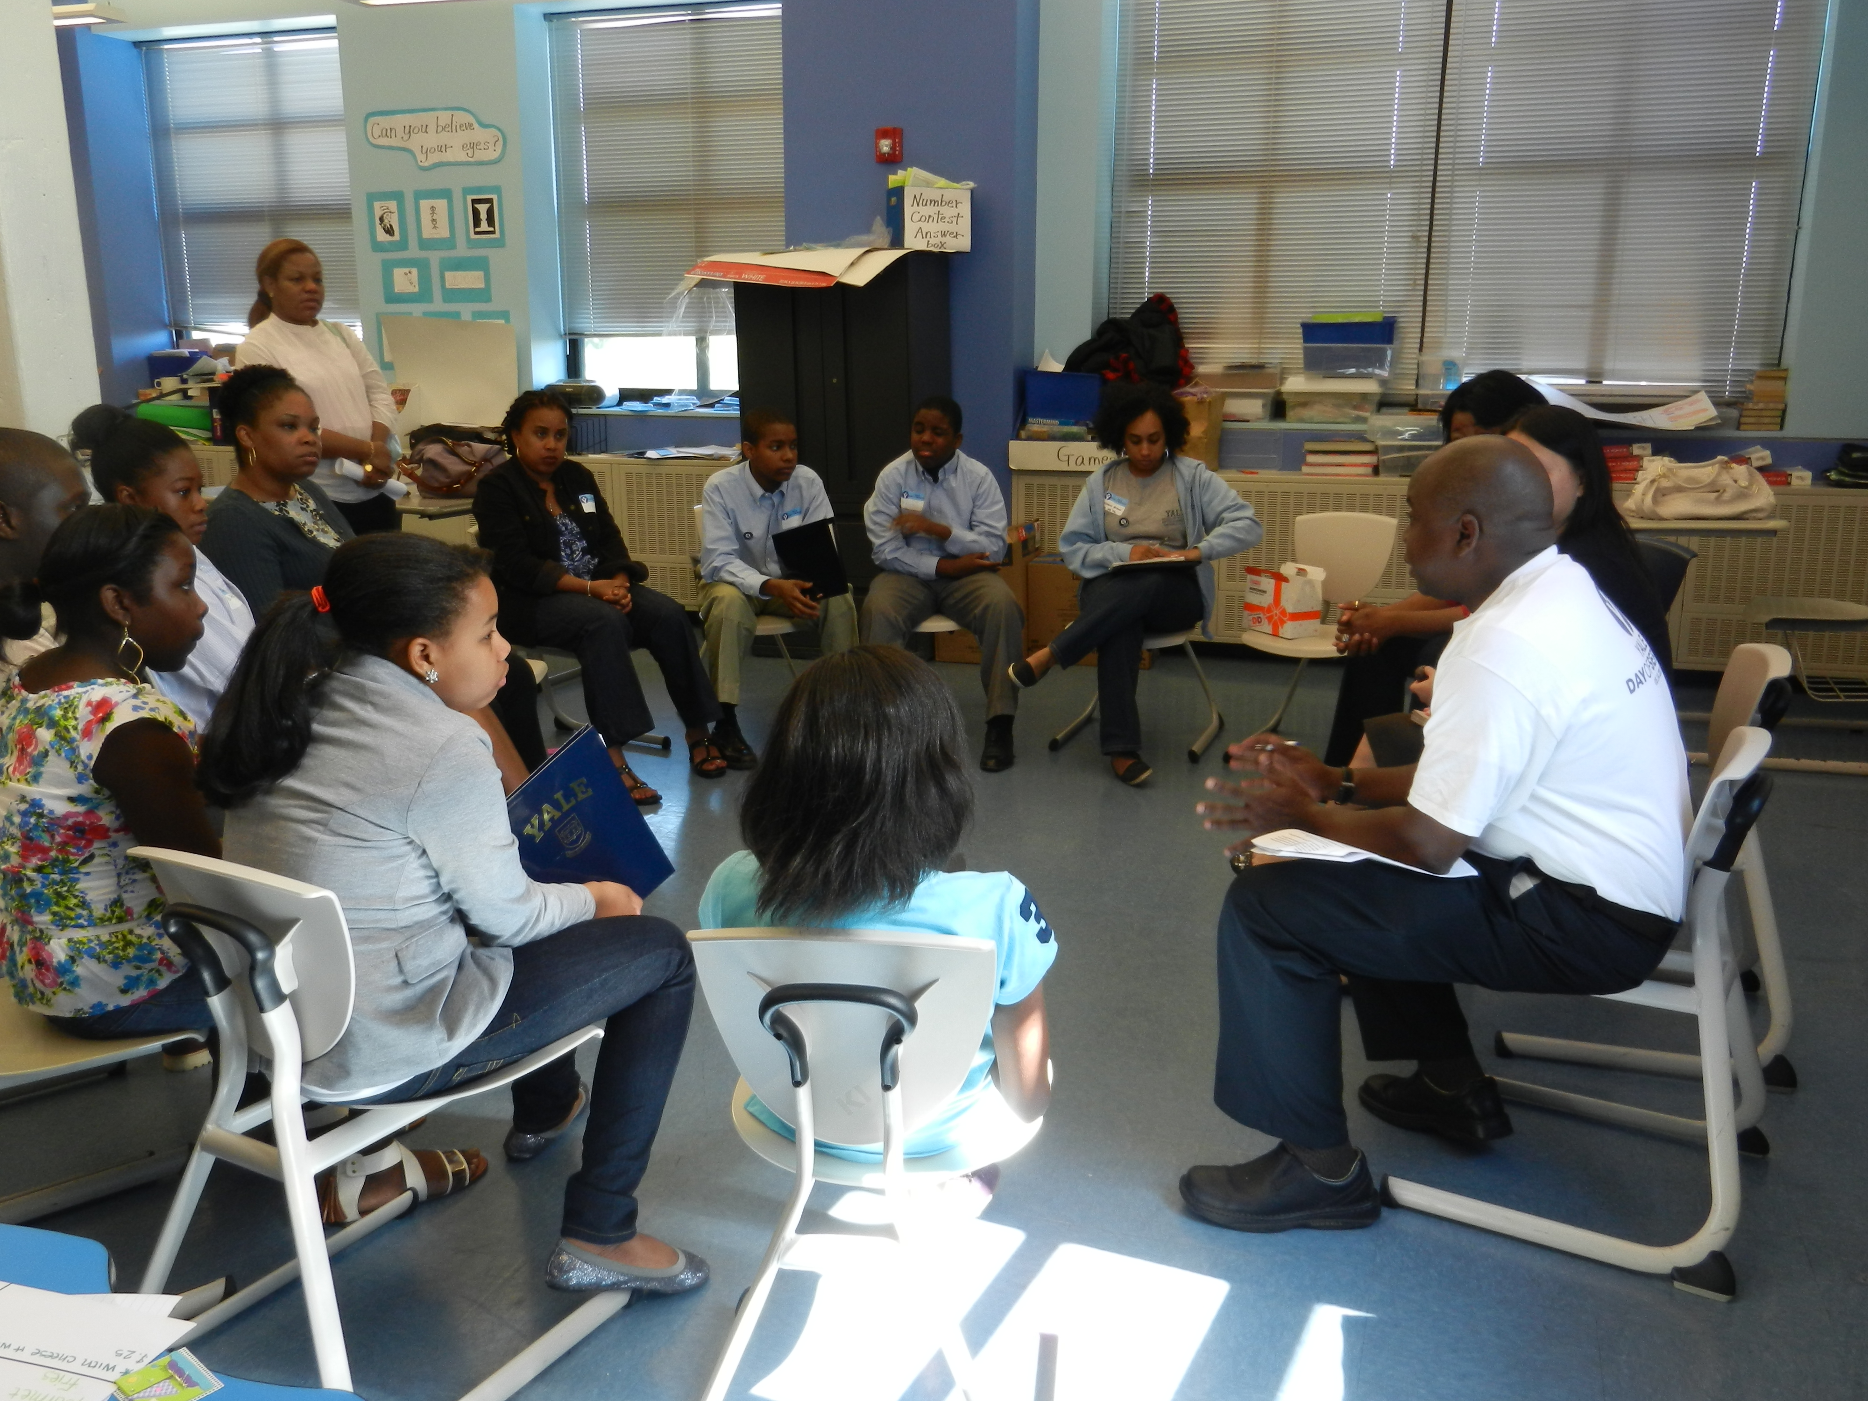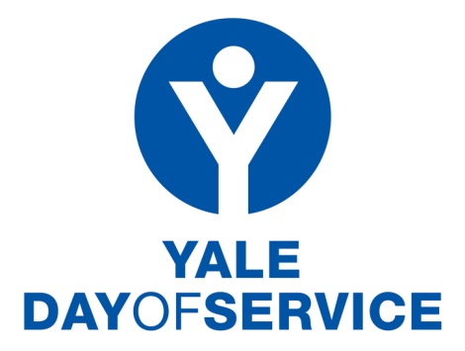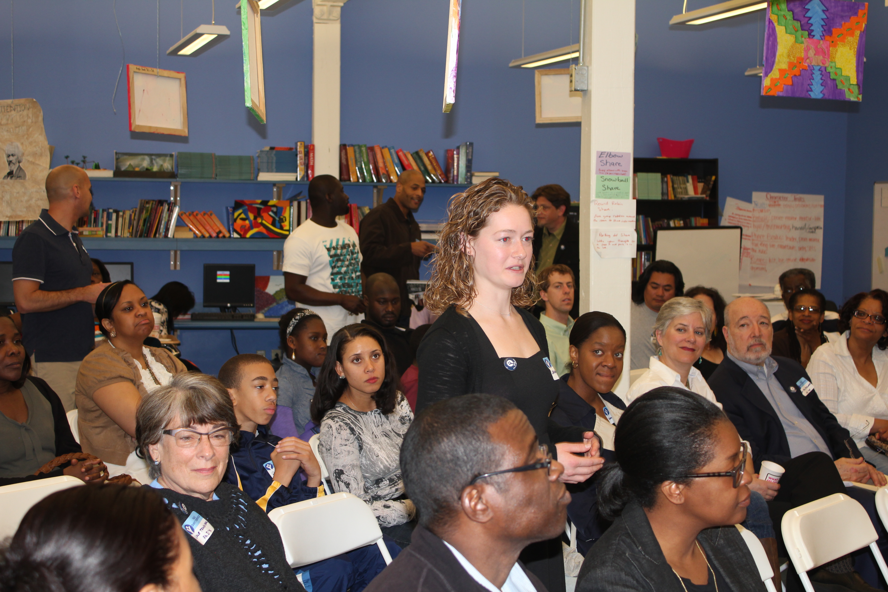
www.yaledayofservice.org
Saturday, May 9, 2015

Project in a Box - Career Explorations

Overview: Several Yale Day of Service (YDoS) sites have wonderful success with Yale alumni sharing their various career paths with students. It is a terrific way to make a difference in a young person’s life and give back to our local communities. Being a mentor by just being yourself can change the life of a child and inspire them to do great things. Shared by a Yale alumna, “When you are working with children one-to-one, you can really feel the difference you are making right then and there. Seeing the smile on a child’s face, that is why we all volunteered today, to inspire them and help them dream.”

Since several YDoS alumni volunteers have asked how to re-create this program in their own regions, we thought that it would be helpful to provide a step by step plan on how to implement this program. Below you will find the Career Explorations; “project in a box,” a working plan to use and change to fit your area or need. Consider it as a road map to help you create your own program.

Target Audience:
- Students: Select age group - elementary, middle or high school students.

- Parents: Parents are often invited to attend, especially with younger children. Some sites have included a separate break out session with parents to discuss how to encourage children to learn about different careers and/or to assist them in their own career development.

Volunteers:
- Yale alumni, families and friends. Older children can assist by occupying younger
children who come with their parents, but are not old enough to be involved with the
career program so parents may participate fully.

- In locations with multicultural backgrounds, some programs have focused on specific
needs and have engaged Spanish speaking or other bi-lingual volunteers.

Location:
Any school in your area or community center, library or other public space while partnering with a school.

Length of Time:
- Program generally runs approximately three hours, 9am-12pm, or longer with lunch.
- Tentative program schedule:
- 8:30am – Yale alumni, family & friends arrive early and briefed by Site Coordinator.
- 9:15am – 9:40am. Welcome remarks and overview.
- 9:45am – 10:20am. Break Out session 1 (35 minutes sessions).
- 10:30am – 11:05am. Break Out session 2.
- 11:15am – 11:50pm. Break Out session 3.
- 12:00pm – Closing review and sharing stories.
- 12:15pm – 1:00pm. Optional lunch and continued sharing stories in small groups.

What‘s Needed:
- General Assembly room (gym, auditorium, or cafeteria) for welcome, overview, program and closing review.
- Individual classrooms for small group sessions by area of career interest. Presenters from all career paths are welcome and encouraged to participate. Career fields that have been presented in the past include:
Arts/architecture
Banking/finance/insurance
Business/advertising
Computer science/digital arts
Education/teaching/special education
Engineering/construction/real estate
Entertainment industry/food service
Journalism/publishing/newspaper media
Law/judge/elected officials/police
Medicine/nursing/public health/counseling
Non-profit organizations
Sciences/research
Sports management
Start-ups
(Classrooms are divided by student age as well as career interest)
- Kitchen or area to serve refreshments or lunch.

Process:
- Contact your local school principal to introduce idea of a volunteer service project, Career
Explorations, and set up site plan. Benefits to the school include the opportunity to
introduce young adolescent (or teen) students to possible career paths shared by a diverse
group of Yale alumni and possible development of a sustainable mentoring program.

- Recruit Volunteers. Working with your local Yale Club, reach out to all alumni in your area and ask them to come share their own career experiences with the students and parents in the school.

Sample recruitment and informational emails that were sent to the Yale community to solicit alumni volunteers for the program are attached at the end of this document.

Role of Yale Alumni, Family and Friends:
Since every school is different and the ages of student participants will vary from school to school, the school principal will guide the site coordinator and volunteers on what to focus and specifically address in the project. Find as follows a series of sample questions which could be considered or asked by the participants. Feel free to develop your own based on your particular school and age group.

In addition, some alumni might want to target working with the parents and could help with resumes and interviewing skills.

- Be yourself and tell your story.
- What is your career or job now? If in transition, what are your plans?
- What did you do to get this job?
- How long have you been in this line of work?
- What do you actually do in your job? Can you describe what you do day-to-day?
- What industry are you in and can you describe it?
- What things were planned? What things happened by surprise?
- How does your career build on a series of jobs?

    - Share what is important to you and what inspired you in this career path.
- Why do you like your job? Dislike, and how do you deal with it?
- What inspired you to find this job and career?
- What did you do to prepare for the job and career you have now? Skills, education, training, volunteer work, or something else?
- How do your outside interests and hobbies help you find your career?

- Talk about what classes you took in school and what else you did for your career.
  - How was school helpful to you? Courses?
  - What did you enjoy in elementary, middle, and high school? College? Graduate
School?
  - What did you take in school which turned out to be really important in your career?
  - What extracurricular activities, sports teams, volunteer work, or part-time job did you
find helpful in developing your career?

- Explore different jobs along the way.
  - What jobs did you do before the one you are in now?
  - What did you think at the time was a waste of time, but turned out to be an important?
  - How did you go about to find these jobs?
  - Did you have a mentor and how did you develop this relationship?
  - What is networking and how did you go about creating your own?
  - Describe the different skills you acquired through a variety of jobs.

  - Explain how your career plans have changed over time.
    - Where did you start and where are you now? Future plans?
    - How has your job changed since you started?
    - How have you stayed current? Skills, education, and training?
    - What is important to you in your career? How has that changed over time?
    - How do you balance your career with family, hobbies and outside interests?

    - Be open about how you dealt with uncertainty, surprises, mistakes and changes.
      - What positive and negative surprises have you found in your career or job?
      - What is it like not knowing how things will turn out?
      - What mistakes have your made and what happened? What did you learn?
      - What things went wrong, but turned out to be positive for you?
      - How do you deal with boredom?
      - How do you juggle a lot of work coming all at the same time?
      - What things if you knew now would have made a difference?

      - Enjoy answering the students’ questions and turn the questions to the students.
      - What do you like to do? In school? Outside of school?
      - Have you thought about a possible job/career which might interest you? What do you
like about it? What skills do you think you will need?
      - In this world in which we all live, change is constant. Given that, what kinds of jobs do you think you would like to have over time? How are do they relate, or not?
      - How do I learn about your industry – engineering, electronics, teaching, law, etc.?
      - What advice would you give me?

      - Inspire students’ curiosity to explore different career ideas.
      - How do you like to spend your free time?
      - What do you enjoy doing the most?
      - What kind of people inspire you and why?
      - If you had a magic wand, what would you like to be when you grow up?

Prior to Actual Project Days:
- Market project through local Yale Clubs and Associations. Promote through the website – www.yaledayofservice.org. Post on Yale Day of Service and your personal facebook pages, Twitter @YaleDayService and #YaleDayService, Instagram, and email.
- Encourage participants in all careers, including those in transition.
- For project site, group volunteers by career interest.
- Discuss with school administration how to group students who participant, age, etc.

On the Actual Project Day:
- 45 minutes before children arrive – Site Coordinator welcomes Yale Alumni, gives an overview of the day, and answers questions.
- First 30 minutes – Welcome Address. General assembly with introductions by school administration, students and parents (depending on age of students) and Yale alumni, family and friends. Each Yale volunteer makes brief remarks about their current career and/or career path and their enthusiasm for being at this program.
- Depending on the time schedule, there can be three 35 minute Break Out sessions so children can explore different career areas during the morning.
- Break Out session by career field with 1-2 Yale alumni and 4-5 students, depending on the age, is optimum. The groups can be larger or smaller depending on the volunteer response and student participation; however, smaller is better for story telling and answering questions.
- Closing review – All participants come back together to share stories in the General Assembly room.

Media:
On the Day of Service, be sure to capture the excitement with stories, photographs, brief videos and share on the Yale Day of Service facebook and your personal page. Twitter tweets to @YaleDayService. Include #YaleAlumni and #YaleDayofService on your Facebook and Twitter posts. Email photos to Alisa Masterson, Assistant Director of Alumni Relations, alisa.masterson@yale.edu.

Supplies:
- Individual signs for Break-Out classrooms, masking tape to post on doors; large master sign with schedule.
- School building layout handouts with Break-Out classrooms.
- Water for all participants.
- Yale banner, pennants, etc. to hang.
- Yale name tags and markers.
- Suggest wearing Yale or Day of Service shirts (purchased in advance from the www.yaledayofservice.org) or other Yale clothing.
- Camera, ipad, and/or smart phone for live media postings.
- Optional refreshments or lunch at end of program.
- Distribute main Yale brochure from Undergraduate Admissions or Visitors’ Center; pencils or folders from Campus Customs (possibly donated or purchased by volunteers).

Sustainability:
- Program can be sustainable based on school and alumni collaboration on monthly weekends or during holidays.

After Program:
- Write thank you note to school administration and volunteer participants.
- Post comments, photographs and short videos on Yale Day of Service facebook page.
- Submit small article and photos to local online and print media.
- Share your experience with your class notes, Yale College, Graduate or Professional Schools, SIGs, World Fellows, etc.
- Complete site survey.
- Discuss sustainability with school administration.

Questions:
For questions and suggestions, please contact Lise Chapman, lisepchapman@gmail.com, or Alisa Masterson, alisa.masterson@yale.edu, 203-432-1947.

Thanks again for all you do for Yale!

Lise Chapman ’81 MBA
Chair, Yale Day of Service

 http://www.yaledayofservice.org/
Like the Yale Day of Service on facebook!
Twitter - @YaleDayService, #YaleDayofService

Example of an actual email sent to Yale alumni - 2012:

Career Explorations Day

Come and Share your Career with Students
St. Philip’s Academy, Newark, New Jersey
Saturday, May 12, 2012

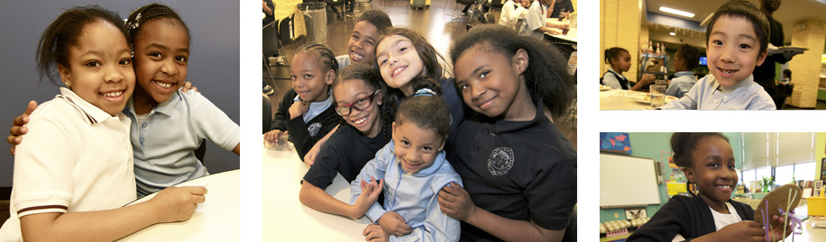

Yale Day of Service Co-Sponsors:
Association of Yale Alumni in Medicine
Association of Yale Alumni in Public Health
Students and Alumni of Yale
Yale Alumni Association of Bergen County & Vicinity
Yale Alumni Schools Committee - Hunterdon & Warren County
Yale Alumni Schools Committee - South Jersey
Yale Black Alumni Association*
Yale Club of Central New Jersey
Yale Divinity School Alumni
Yale Graduate School Alumni Association
Yale School of Management Alumni Association
Yale School of Management Education Club
YaleWomen NYC
-------
*Special Note: Sponsorship is held in memory of Janifer Lighten, Y'83,
Inaugural President and Chair of the Yale Black Alumni Association.

Participation Event:
Come join Yale alumni, families and friends throughout New Jersey and the tri-state region who will meet together to share different career opportunities with 6th to 12th grade students and a separate group with their parents.

Talk about what you do in the public, private and non-profit sectors; military service; your traditional and non-traditional career paths; role of education; summer explorations; and additional experiences in different jobs, internships, and volunteer service.

After the introductory remarks, we will break into smaller groups of students by field of career interest; 8th to 9th grade private school application process group; 11th to 12th grade college process group; and career conversations with parents.

St. Philip's Academy is inviting students from several public charter and other public schools in Newark to attend this program. Following this initial career explorations day, longer-term volunteer opportunities, including classroom reading, practice interviewing, and mentoring can be developed on an individual basis with St. Philip's Academy and other schools in Newark.

How to Sign-up:
Go to: www.yaledayofservice.org. (Service Sites: NJ. Newark. Career Explorations Day - St. Philip's Academy). All participation is done directly by signing up on the AYA Yale Day of Service website. In the return reply email, please indicate your field(s) of career or discussion group interest, preference with students or adults, and your Yale affiliation. Children of volunteers are not able to participate at this time.

Time:
Registration begins at 9:00am. Program runs from 9:30am-12pm.

Lunch will be provided. We will begin with an overview, and then break into smaller groups by career field or application process discussion with students or their parents. We will come back together, share lunch and exchange experiences.

Location:
St. Philip’s Academy
342 Central Avenue
Newark, NJ 07103
Website www.stphilipsacademy.org
Phone 973-624-0644

Background:
St. Philip's Academy is a 20 year-old institution which seeks to provide a rigorous academic and moral education to elementary and upper school (grades 5-8) children of the city of Newark and its environs. St. Philip’s, a school in the Episcopal tradition, strives to create within its students a love of learning, an intellectual curiosity, and a sense of duty to the community that will enable them to make thoughtful and morally informed decisions throughout their lives.

Leadership qualities are developed in a culturally diverse experience. The School exists to provide a unique educational opportunity for capable students, regardless of their ability to pay, enabling them upon graduation to be successful in the most selective secondary schools in the nation. St. Philip's seek to provide a model of educational excellence, thereby contributing to the revitalization of the city of Newark.

Site Coordinator:
Questions? Contact Lise P. Chapman, ’81 MBA / YDoS Regional Director: lisepchapman@gmail.com.

Directions and Parking:
- North or South via Garden State Parkway: Take Exit 145 to Route 280 East. Follow directions for Route 280 East.
- North or South via New Jersey Turnpike: Take exit 15W to Route 280 West. Follow directions for Route 280 West.
- Route 280 East: Take the First Street exit (left exit) – Exit 13. At the light, make a right onto First Street. Go straight through the first traffic light and at the second traffic light make a left onto Central Avenue. Continue to 342 Central Avenue. The school will be on your right.
- Route 280 West: Take Exit 14A (Clinton Ave.). Proceed to the traffic light and turn left onto Norfolk Street. Continue 3 blocks to Central Ave. and turn right. The school will be on the left 2 blocks down.
- Route 78 East: Take exit for Garden State Parkway North and follow the directions above.
- Parking is available in the lot across from the school and on Duryea Street.

Yale Day of Service: We look forward to seeing you on Saturday, May 12th!

3/21/12

Example of Second Email Sent to Paticipants - 2012
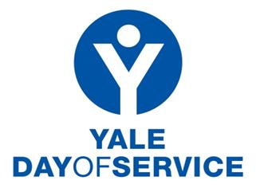
April 19, 2012

Dear Yale Alumni for our YDoS Career Explorations Day,

Thank you so much for signing up to attend our initial Career Explorations Day at St. Philip's Academy, on Saturday, May 12 from 9am-noon. We are going to have an incredible day!

So far as of April 19th, we have only 10 Yale alumni participants, so please get the word out to your friends, families, neighbors and colleagues to come join us! They can go directly to www.yaledayofservice.org, then Service Sites, then NJ, then Newark - Career Explorations Day - St. Philip's Academy and signup. You can also sign them up as your guest. We need all ages, walks of life, and different career experiences to share with these students. This is our very first project like this anywhere by Yale alumni and we want it to be a big success for these children, their parents and these schools!

Given the preliminary interest by students and their parents, we probably will need 35 or so adults to cover the number of students 6th-8th grade from St. Philip's, Robert Trent and North Star charter schools, so please get the word out to sign up. We also encourage walk-ins on May 12th, but we can plan better with earlier notification.

For the morning, we will break into small groups by career topic, private high school application process; resume writing and interviewing skills for the students. We will also break into small groups to help many of the children’s parents who are in job and career transitions.

St. Philip's would love to profile some of you all who have already signed up, so please let me know if you would like to help. They will do a little write-up of you, your background and career path and share it in their literature with the students and parents.

So, please let me know when you get a chance:
1. Your Yale background and degree
2. Your current career interest or career path
3. Your area of interest on May 12th (with students – career discussion or private high school application process; or with parents – career and job networking advice, resume writing, job interviewing skills)
4. If you would like St. Philip’s to contact you for a possible profile to share with the students. Please let me know your best contact information for the school to reach you.
5. Ask a friend to join you on May 12th and direct them to www.yaledayofservice.org to sign up now
6. How you have heard of this project?

Please feel free to contact me with any questions. My cell is (number). I look forward to meeting each one of you on Saturday, May 12th!
Thanks again,

Lise P. Chapman, ’81 MBA / YDoS Regional Director:
Yale Day of Service: We look forward to seeing you on Saturday, May 12th!

3.8.14

