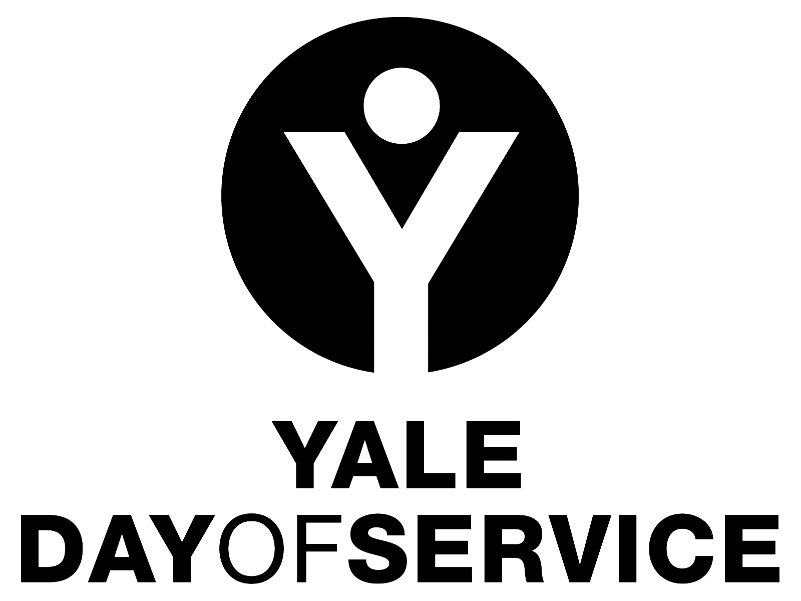
Yale Day of Service
Organizational and Planning Timeline

Late September to Mid-November

- Regional Directors contact local club presidents to confirm/encourage club participation in the Yale Day of Service for the following May.
- Local Club Coordinators for the Day of Service are identified and provided with job description and timeline (both available at the Day of Service Toolbox on the Yale Day of Service website, http://yaledayofservice.org/); Regional Directors work with YAA staff to assist in targeting alumni to recruit as local Day of Service leaders as needed.
- Clubs are encouraged to include Yale Day of Service information in local communications throughout the year as well as promoting it at club events and activities.
- Identification and recruitment of sites and site coordinators begins.
- Day of Service leadership development and resource sharing at the YAA Assembly in New Haven
- A Save the Date email blast is sent to all alumni from New Haven to launch the Day of Service project year

January
- Identification and recruitment of sites and site coordinators continues.
- Staff contacts at service sites are established; Day of Service volunteer project responsibilities are developed and logistics are confirmed.
- Site forms begin to be submitted at http://yaledayofservice.org/
- In New Haven, YAA staff manages the site collection information and webpage with site listings by geography.

February
- The “big push” to get sites submitted. Regional Directors are in regular contact with their local volunteers to encourage the submission of sites.

March
- Registration for Yale Day of Service sites goes live!
- Blast message to all members of the Yale community around the world when the Day of Service site registration website goes live at http://yaledayofservice.org/.
- Day of Service volunteer leaders have weekly access to participant enrollment
  - Local coordinators send additional confirmations to each registrant with specific logistical information (see sample memo posted in the Yale Day of Service Toolbox)
- Local promotional efforts to recruit additional Day of Service volunteers ramp up.

April
- Registration outreach continues. Some sites may be filled and clubs may consider adding additional sites as needed.
- Local clubs may discuss purchasing Yale Day of Service merchandise as an incentive or gift. Information on how to do that can be found on the home page of the Yale Day of Service website.

May
- Final details of the service projects are confirmed with project staff.
- YAA staff mails “day of” materials to site coordinators (i.e. nametags, lapel pins, signage, and more!).
- Local chairs send logistical reminders to all registrants

ACTUAL DAY OF SERVICE
- Site coordinators arrive early to meet and greet both project staff and Yale volunteers (see the Site Coordinator job description in the Day of Service Toolbox at yaledayofservice.org.
- Take pictures and/or video of your excellent Yale Day of Service volunteers hard at work! Post them to the Yale Day of Service Facebook page, Twitter account and/or Instagram account as well as to your own. Then submit the best to the Yale Alumni Magazine’s photo contest.
- Celebrate the successful completion of the Yale Day of Service!

Follow Up
- Send a thank you to the project staff you worked with to coordinate your Day of Service(s). If the site worked well, consider asking for a commitment for next year’s Yale Day of Service.
- You, or one of the participants at your site, should tell the story of your day at the “Share Your Experience” tab on the Yale Day of Service website, www.yaledayofservice.org.
- Send thank you’s to all those members of the Yale community who participated…but we do not recommend soliciting them for club dues as your follow up! Let them know how happy you were to have them and invite them to participate in future club activities, perhaps providing them with some contact information for a person or for your club website if you have one. Some clubs send appreciation certificates to participants; samples can be found in the Organizer’s toolbox at yaledayofservice.org.
- If your local club does not already do so, consider instituting a more regular volunteer opportunity at one or more of your Yale Day of Service sites. This could be one other time per year, per quarter, per month or whatever might work for you locally.

If you have questions about planning for the Yale Day of Service, please feel free to contact the Regional Director for your area (found under the “Contact Us” item at the top of the Yale Day of Service website), or Yale Day of Service staff person Joao Aleixo (joao.aleixo@yale.edu) at the Yale Alumni Association.

