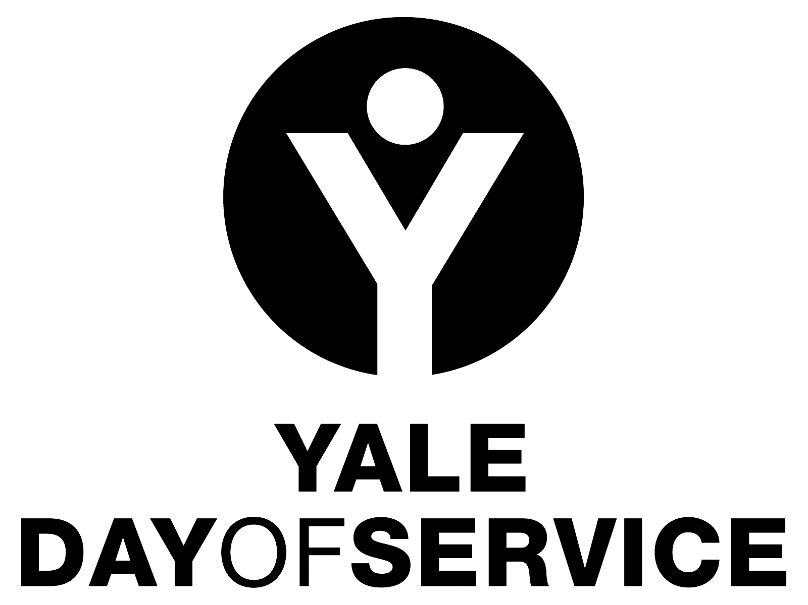
Yale Day of Service
CLUB and SITE COORDINATOR DUTIES

Thank you for your interest in helping out with the Yale Day of Service! The success of your local Yale Day of Service program will depend on many factors, but having a local volunteer who is willing to take on a leadership role is perhaps the most critical. Following is a general overview of the tasks involved in managing the Yale Day of Service in your community.

- INVESTIGATE POSSIBLE SERVICE SITES.
Talk to members of your Yale Club Board and/or to other Yale alumni in your area to solicit ideas for local non-profits that might be good sites for a Yale Day of Service activity. Alumni may work in these organizations, and we know that many Yale alumni share their time and talents on Boards of local non-profits. They know these organizations well and will have a good idea of which ones are well suited to a possible Day of Service activity. Keep in mind that there is great interest in family friendly sites so ask about age restrictions and other limitations. If you are considering more than one site for your area, think about including both outdoor environmental sites as well as sites where participants will be working directly with others such as tutoring or serving in a soup kitchen. Also, while we encourage scheduling Yale Day of Service activities for Saturday, May 9, please know that hosting Yale Day of Service activities on other dates due to local conflicts or religious considerations is just fine. And, we suggest that you look at sites that accept a minimum of 5 volunteers so there will be the opportunity for a sense of Yale community among the participants.

Your Regional Director also has information on the kinds of sites you might think about. Please refer to the Site Selection Guidelines for other information on locating a site.

- SELECT SERVICE SITE
You may be working with a committee or other group of interested alumni as you plan the Day of Service and thinking about the options for service sites as a group can be helpful. It also helps to create a broader sense of ownership for the activities of the day. You should look at geography, types of sites, and capacities as you make your selections. If you are doing multiple sites, we strongly suggest that you have a Yale alumni volunteer to serve as the coordinator or host for each site. Information about the suggested duties for that person includes all of the following items below. The Club Coordinator will need to be sure that each of the site coordinators is working on these items:

- WORK WITH SERVICE SITE STAFF REGARDING PROJECT DETAILS AND SUBMIT YALE DAY OF SERVICE SITE FORM.
Ask the director of the potential agency or site partner to come up with a detailed scope of work, a list of any pertinent materials, and the hours of service desired. The commitments can range from 2-4 hours of work to an entire day. Once you have the scope of work you can determine volunteer capacity and any materials you will need to bring to execute the work. Then fill out the Yale Day of Service Site selection form for the Association of Yale Alumni (AYA) which is at https://alumni.yale.edu/registration/dos/sitecollector.php so it can be included on the Yale Day of Service website. Please notify your Regional Director and any other local Yale Club leadership when you submit the form so they are aware of the site or sites where the Yale Day of Service will be occurring in their region.

It is advisable to do an in-person, on-site run through of the scope of work within one or two weeks of the event. Check to see if there is an appropriate area where the Yale group can meet to sign in for the day and get their Day of Service nametags and pins when they arrive on-site.

- COORDINATE WITH YOUR LOCAL CLUB PRESIDENT AND REGIONAL DIRECTOR
Keep in touch with your local Yale Club President and Regional Director so they are aware of your progress in Day of Service planning. Also, while the AYA will be doing overall promotion of the Yale Day of Service to all alumni, it is very important that your events are promoted locally as well. Your club leadership likely has communication mechanisms and you need to work with them to get the word out. (If you do not have a functioning local club in your community, contact your Regional Director who can get alumni lists for your area for direct Day of Service outreach).

- ASSIST IN RECRUITING VOLUNTEERS FOR YOUR SITE AND OTHER SITES.
Similarly, you and your committee, if you have one, should also help in volunteer recruitment. Spread the word to your Yale friends, send our personal emails…be creative! Encourage those you know to register for the Yale Day of Service at www.yaledayofservice.org (the site listings registration page will be live in early March).

If your site had a maximum number of volunteers and that number is reached, the registration function will be turned off and a message stating the site is full will be posted. It will note that alumni can contact you to see if there will be a wait list for the site.

If your sites are filling up quickly, you might want to consider adding more! (We can make late additions if capacities have been reached).

- SEND OUT CONFIRMATIONS TO THE REGISTRANTS FOR YOUR SITE OR SITES
The AYA will send weekly lists of those who have registered for your site. Registrants need to get a local confirmation from you, and we suggest the following be included: a thank you from you, confirmation of the site for which they registered, the address for the site, directions, parking information (if applicable), what to wear and/or bring, the time and location of where they should meet to register and get their assignment, and, for outdoor sites, what to do if it rains on May 9th. The message should also include a contact name and number for that site on the day of (generally the Yale volunteer coordinator for that site) and contact information for the person sending the email, if different from the coordinator.

- FIELD GLOBAL DAY OF SERVICE QUESTIONS FROM PARTICIPANTS FROM NOW UNTIL THE DAY IS DONE.
Since the name of the Club Coordinator for the Yale Day of Service or the individual Yale volunteer site coordinator will be listed on the AYA Day of Service website as the contact for your site or sites, registrants may be in touch with that person to ask specific questions or to clarify information. If a registrant needs to change or cancel their registration, they should contact Alisa Masterson at the AYA at alisa.masterson@yale.edu.

- ORGANIZE ALUMNI AND FRIENDS ON SITE ON MAY 9th
Please plan to arrive early at your site on May 9th and stay until the work is done. You have already been in touch with the agency supervisor about your registration location and hopefully have arranged for a table or other area where you can check in your volunteers, have them fill out the Yale Day of Service nametags and give them their Yale Day of Service buttons (both provided by the AYA). Don’t forget pens and Sharpies!

Post any signage or entrance information, and/or have another Yale volunteer greet participants and help direct them to the registration area.
We find that it really helps to create a sense of Yale community as well as a sense of purpose for the work if you take a few moments before you begin to talk to the group. You, or a member of the organization’s staff, can take a few minutes to describe the mission of the organization and perhaps the work that the group is to do as well as what that work will mean to the organization and the clients served. Introduce yourself and the agency staff, and have the volunteers say their name and perhaps Yale affiliation or other information that will help the group to get to know each other a bit before the work begins.

Then, direct participants to jobs or refer them to an on-site agency person who can direct them to work. Be sure that the alumni all have a job to do!

We know that most local Day of Service programs do not have any funding, but be creative to see if you can find a way to provide water or snacks to the volunteers. Perhaps an individual or organization (or in some cases, the Yale Club) would be willing to support the day in this way. Sometimes the hosting organization makes refreshments available as well.

Plan to have someone take pictures and/or video. These can be used in many ways including emailing them to the participants after the event, posting them on the local club’s website, submitting them to the Yale Alumni Magazine Day of Service photo contest, and promoting the Day of Service for next year. Please be sure to send the best photos and videos to the AYA as well. They may post them on their website or use them for promotion of the program!

- IF POSSIBLE, DEVELOP A RAINY DAY PLAN.
If your site is an outdoor site, discuss the rain plan with the organization contact. Often the work goes forward unless it is pouring rain, but in this case your no-show rate is fairly high. In some cases an indoor alternative activity such as stuffing envelopes for a mailing can be a backup. Or, you may want to try and plan for a rain date (which should be included with the site information for the AYA website, if possible).

- ORGANIZE A CELEBRATION / SOCIAL GATHERING.
After an exhilarating Day of Service, celebration is fun! If possible, it is wonderful for the volunteers to share some post-service time socializing and sharing stories of the day, especially if there is more than one site in your club area. Some clubs host a barbecue or let people know in their confirmation message that they should plan to bring a picnic lunch for after the service activity. Some clubs designate a centrally located restaurant where alumni gather as they finish their work. It is up to you to decide how/if this will work, but we know that many alumni really enjoy the opportunity to build on the friendships they made during the day and bask in the glow of their achievement.

If you have questions about serving as a coordinator for the Yale Day of Service in your area, please contact (Regional Director/and/or club president/and/or Alisa Masterson at alisa.masterson@yale.edu). Thank you for helping Yale alumni to make a difference in your community through the Yale Day of Service!

