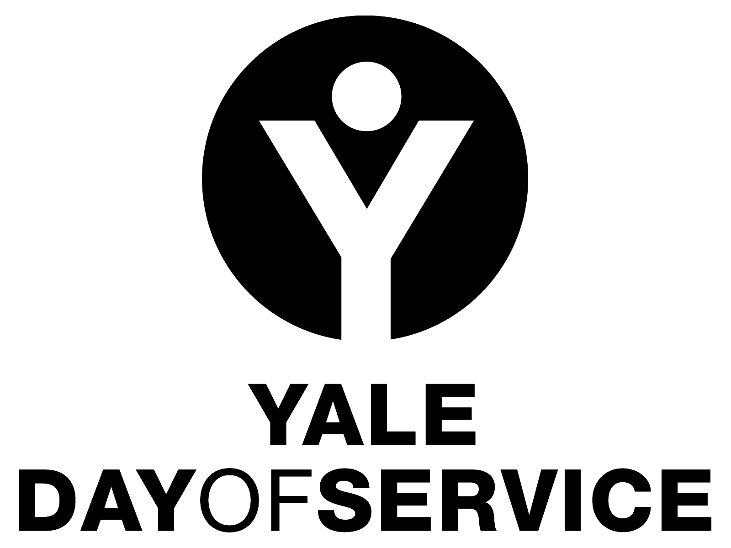

Sample Text for Outreach Message to Club Presidents

This message may be sent out as a letter or cut and pasted for use as an email.
Please feel free to edit as local circumstances merit.

Club President Name
and Address

Re: Yale Day of Service 2015: May 9th, 2015

Dear Name:

The planning process for the Yale Day of Service in 2015 is well underway and we are hoping to make it even more successful this year than it has been in the past!

Your club did a great job with the Yale Day of Service in 2014 and I hope you are committed to being involved with this great event once again. The Association of Yale Alumni is working to increase participation in the program for 2015 to even more than the 4,000 members of the Yale community who participated nationally and internationally last year…and we need your help to accomplish that goal.

OR

I know that there have been challenges to organizing a Day of Service project in your Club’s area in the past, but I am optimistic that we can make the program a reality locally this year. The Association of Yale Alumni and I are available to assist you in the process and hope you are willing to work with us to bring this exciting program to your club. It has been wonderful to see the many ways in which Yale alumni have made a difference in their local communities through the Yale Day of Service in previous years. Each year, nearly one third of those alumni who register for the Yale Day of Service have never been involved with other local club activities, and so the Yale Day of Service has brought new volunteers and new energy to the clubs that participate. I hope yours will be one of them this year.

The first step is to identify and recruit someone to serve as your club’s coordinator for the Yale Day of Service. This person will spearhead the effort of finding service sites, getting the message out, and developing strong registration numbers. (A job description for the Club Coordinator, as well as other reference documents that will help your club as you plan the Day of Service can be found in the Toolbox on the Yale Day of Service website at www.yaledayofservice.org). If you already have someone to lead the program for your club, please forward me his or her contact information so that we can work together. If you have not identified a person or last year’s coordinator is not available this year, I may be able to help you find someone with assistance from the AYA. I can also assist you in finding projects and venues for volunteering if you need that kind of help.

I hope you will email or call me so we can talk about the Yale Day of Service in your club area. If I do not hear from you by (date), I will give you a call to follow up. I am here to support and assist you in any way I can to be sure that you club sponsors a successful Yale Day of Service. I look forward to working with you and hope to hear from you soon.

Sincerely yours,

(Contact information)

cc: Alisa Masterson

