“T
he justification of a university is to be found in the service which it gives to the nation and the world.”

Yale President Charles Seymour
Yale College class of 1908, PhD 1911

Yale Day of Service
www.yaledayofservice.org

For more information, contact:
Alisa Masterson
Association of Yale Alumni
P.O. Box 209010
New Haven, CT 06520-2090
203.432.1947
alisa.masterson@yale.edu

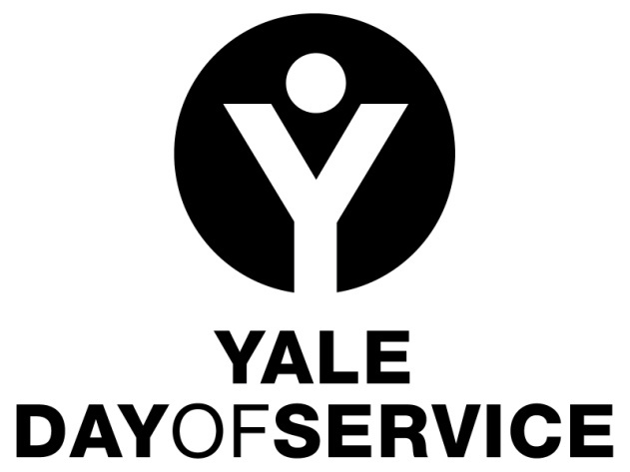

Connecting for Stronger Communities!

May 9, 2015
How can Yale make a difference in your community? Through you!

The Association of Yale Alumni and your local Yale club are presenting you the opportunity to participate in the Yale Day of Service. On Saturday, May 10, 2014, Yale alumni all over the world will come together through the common act of providing service to others.

What is the Yale Day of Service?

Yale alumni have an unparalleled tradition of service. From Dwight Hall’s student-led community based programs to the highest levels of government service, Yale alumni have risen to the challenge to ‘change the world,’ and indeed many are doing just that as volunteers for Yale, or in their professional lives in the nonprofit sector, or serving on boards of foundations, or as elected officials, or by giving of their intelligence and creative energy to volunteer community projects.

The fifth global Yale Day of Service will be held on May 9, 2015, with the goal that Yale alumni around the world will come together on that day to serve their local communities. As in the past, this Day of Service will also serve as a catalyst for ongoing service by alumni and local Yale clubs. It is just one of a number of service opportunities offered by the AYA.

I live abroad…how can I get involved?

If there is a Yale club in your country, contact the club president to offer to help organize the Yale Day of Service in your area (you can find the listing of international Yale Club Presidents on the Association of Yale Alumni webpage at www.aya.yale.edu/find/clubs). Clubs need a coordinator to help select service sites, recruit participants, and organize logistics. And of course we will need participants to make a difference by joining other members of the Yale community in service on May 9!

If there is no Yale club where you live, you can still organize a Yale Day of Service project in your area. Contact Alisa Masterson at the Alumni Association and she can help you plan your project and find other members of the Yale community in your region. You can reach her at alisa.masterson@yale.edu

How do people sign up to participate in the Yale Day of Service on May 9, 2015?

The Association of Yale Alumni will once again coordinate registration for all Yale Day of Service projects through the Web site www.yaledayofservice.org. Sites for 2014 will be available for registrations in early March. It will provide information on all of the Yale Day of Service projects around the world.

What if I want to participate in a project that is not in my local Yale club area?

That’s fine. If you will be traveling or want to come together with your Yale friends somewhere other than where you live, you can register for that site on the Yale Day of Service Web site.

Can members of my family or other non-alumni participate?

Absolutely! The Yale Day of Service is open to the extended Yale community and is also a great family activity.

How can I learn more about the Yale Day of Service?
Check out the Yale Day of Service website at www.yaledayofservice.org. Or, contact the International Chair for the Yale Day of Service, David Sanchez ’84 MA at drsanchez@stonehaven-llc.com.
We hope you will join us on Saturday, May 9th, 2015 as we collectively embody Yale’s great tradition of service to others.

