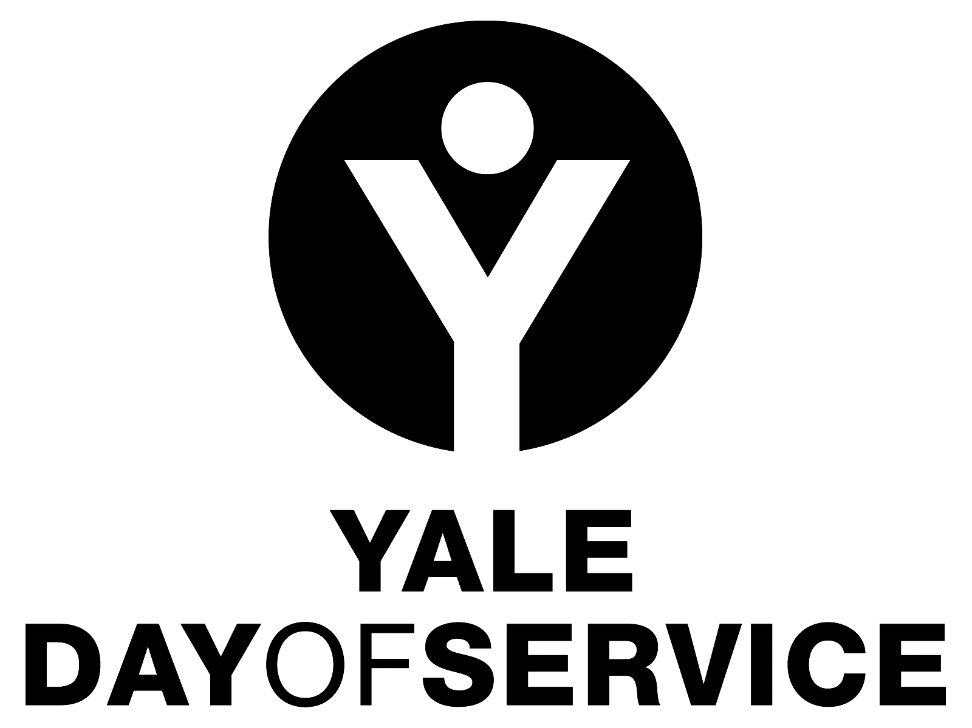
Yale Day of Service
Organizational and Planning Timeline

Late September to Mid-November

- Regional Directors contact local club presidents to confirm/encourage club participation in the Yale Day of Service for the following May.
- Local Club Coordinators for the Day of Service are identified and provided with job description and timeline (both available at the Day of Service Toolbox on the Yale Day of Service website, http://yaledayofservice.org/); Regional Directors work with AYA staff to assist in targeting alumni to recruit as local Day of Service leaders as needed.
- Clubs are encouraged to include Yale Day of Service information in local communications throughout the year as well as promoting it at club events and activities.
- Identification and recruitment of sites and site coordinators begins.
- Day of Service leadership development and resource sharing at the AYA Assembly in New Haven
- A Save the Date email blast is sent to all alumni from New Haven to launch the Day of Service project year

January

- Identification and recruitment of sites and site coordinators continues.
- Staff contacts at service sites are established; Day of Service volunteer project responsibilities are developed and logistics are confirmed.
- Site forms begin to be submitted at https://alumni.yale.edu/registration/dos/sitecollector.php
- In New Haven, the database of sites and webpage of site listings by geography is developed and updated with new site submissions.

February

- The “big push” to get sites submitted. Regional Directors are in regular contact with their local volunteers to encourage the submission of sites.

March

- Registration for Yale Day of Service sites goes live!
- Blast message to all members of the Yale community around the world when the Day of Service site registration website goes live at http://yaledayofservice.org/.
- Weekly registration reports are sent to Day of Service volunteer leaders; additional confirmations are to be sent to all registrants by local coordinators with specific logistics information (see confirmation suggestions memo posted in the Yale Day of Service Toolbox)
- Local promotional efforts to reach out to potential Day of Service volunteers ramp up.

April

- Registration outreach continues. Some sites may be filled and clubs may consider adding additional sites as needed.
- Local clubs may discuss purchasing Yale Day of Service merchandise as an incentive or gift. Information on how to do that can be found on the home page of the Yale Day of Service website.

May

- Final details of the service projects are confirmed with project staff.
- Packages with “Day of” materials are sent from New Haven to site coordinators. These include Yale Day of Service nametags, lapel pins and more!
- Reminders with logistics details are sent to all registrants by local chairs.
- On the Day of, site coordinators arrive early to meet and greet both project staff and Yale volunteers (see the “Day of” suggestions in the Coordinators job description available in the Day of Service Toolbox on the Yale Day of Service website).
- Take pictures and/or video of your excellent Yale Day of Service volunteers hard at work! Post them to the Yale Day of Service Facebook page, Twitter account and/or Instagram account as well as to your own. Then submit the best to the Yale Alumni Magazine’s photo contest.
- Celebrate the successful completion of the Yale Day of Service with a fun event, if possible!

Follow Up

- Send a thank you to the project staff you worked with to coordinate your Day of Service site or sites. If the site or sites worked well, consider asking for a commitment for next year’s Yale Day of Service as well.
- You, or one of the participants at your site, should tell the story of your day at the “Share Your Experience” tab on the Yale Day of Service website, www.yaledayofservice.org.
- Send thank you’s to all those members of the Yale community who participated…but we do not recommend soliciting them for club dues as your follow up! Let them know how happy you were to have them and invite them to participate in future club activities, perhaps providing them with some contact information for a person or for your club website, if you have one. Some clubs send appreciation certificates to participants; samples can be found in the Yale Day of Service toolbox on the Yale Day of Service website.
- If your local club does not already do so, consider instituting a more regular volunteer opportunity at one or more of your Day of Service sites. This could be one other time a year, once a quarter, once a month or whatever might work for you locally.

If you have questions about planning for the Yale Day of Service, please feel free to contact the Regional Director for your area (found under the “Contact Us” item at the top of the Yale Day of Service website), or Yale Day of Service staff person Alisa Masterson (alisa.masterson@yale.edu) at the Association of Yale Alumni.

