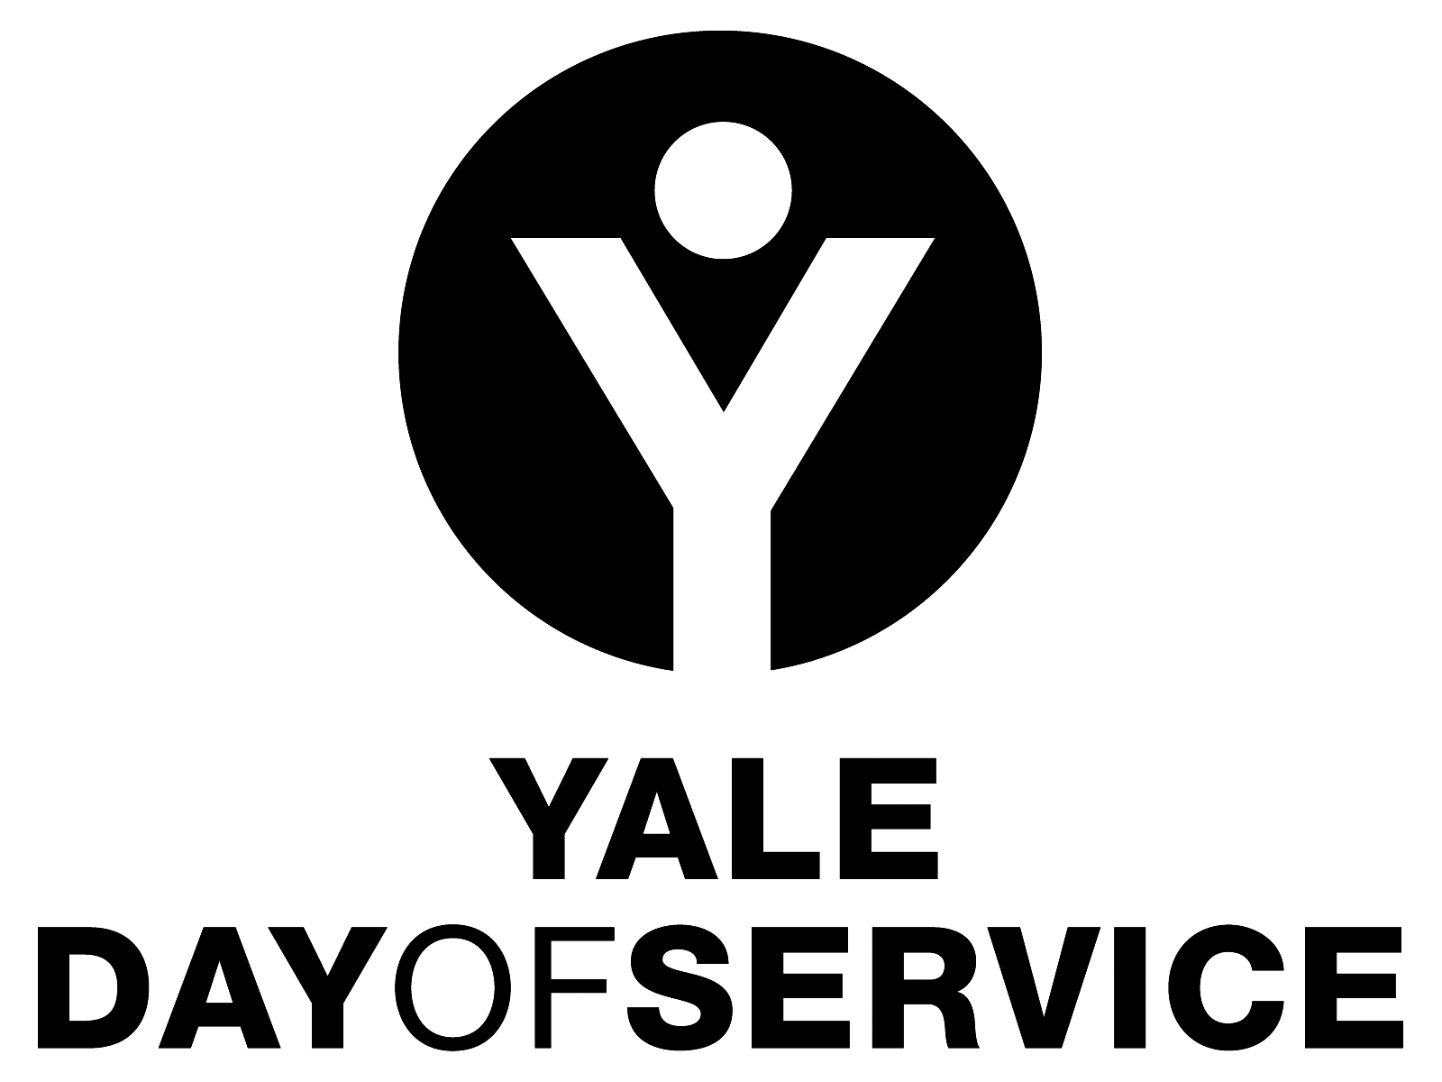
Yale Day of Service
Information for Yale Club and Association Leaders

What is the Yale Day of Service?
Yale alumni have an unparalleled tradition of service. From Dwight Hall’s student-led community based programs to the highest levels of government service, Yale alumni have risen to the challenge to ‘change the world,’ and indeed many are doing just that as volunteers for Yale, or in their professional lives in the nonprofit sector, or serving on boards of foundations, or as elected officials, or by giving of their intelligence and creative energy to volunteer community projects.
The seventh global Yale Day of Service will be held on May 9, 2015, with the goal that Yale alumni around the world will come together on that day to serve their local communities. As in the past, this Day of Service will also serve as a catalyst for ongoing service by alumni and local Yale clubs. It is just one of a number of service opportunities offered by the AYA.
What is the role of the local Yale clubs in the Yale Day of Service?
Your local Yale club will be the foundation of the Yale Day of Service (YDoS). When this project was piloted in the Connecticut Yale Clubs in 2008, it was overwhelmingly successful. Perhaps one of the most interesting outcomes was the way in which it appealed to so many alumni who had never before participated in Yale activities. We believe that this program can help to bring new energy to local Yale clubs by attracting alumni who have not previously been engaged with Yale or their local Yale Clubs. And, by bringing in new people as part of the YDoS planning process, additional volunteer leadership can be developed for your club.
Our club already does service activities. Why should we participate in the Yale Day of Service?
We recognize that some clubs are already engaged in service activities and are aware that in many cases, these activities attract younger alumni or those who perhaps do not participate in more traditional club activities. The Yale Day of Service is an opportunity for those clubs to take their service outreach to a higher level, to reach a broader Yale volunteer audience on a larger scale and to engage new alumni volunteers through the local service planning efforts. It can provide the opportunity to partner with new community service sites or expand the scope of the involvement with groups where you already provide service. And of course the Yale Day of Service provides the singular opportunity to participate in an historic day for Yale as we collectively embody Yale’s great tradition of service to others
How will local clubs manage and implement the Yale Day of Service?
We recognize that a project of this scope cannot just be added to the list of responsibilities for clubs. We have a strong volunteer structure supporting the program led by the National Chair and a cadre of Regional Directors who will provide support and assistance to clubs in implementing the Yale Day of Service. If needed, Regional Directors will assist in identifying a local chair for the Yale Day of Service and can help in recruiting committee members by providing lists of former members of Dwight Hall and former Community Service Summer Fellows who may be in the area. Regional Directors can also assist in finding local service projects, if needed, and have access to projects that can be implemented with the help of national non-profits with whom we are partnering such as the Rotary Clubs and Junior Achievement. In addition, the AYA will provide all clubs with online registration for club service projects, a process which will forward all registrant information to your local club. You can find the contact information for the Chair, Regional Directors and AYA staff supporting the program by clicking the “contact” tab in the left margin of the Yale Day of Service website at www.yaledayofservice.org.
Who is the Regional Director for our area?
Information on Regional Directors can be found online by clicking the “contact” tab in the left margin of the Yale Day of Service website at www.yaledayofservice.org.
What will happen on the Yale Day of Service?
In addition to the actual service activities, we encourage clubs to bring all the volunteers together to celebrate their participation in the Yale Day of Service. This gathering is a social event where those alumni who participated in your YDoS can share their stories and experiences of the day with each other. A picnic or cookout would be a great way to come together and celebrate being part of the larger Yale community engaged in service on this day.
How will other Yale groups be involved?
Other groups such as Yale College classes or shared interest groups may want to come together in your area around a service project for the Yale Day of Service. The will need to be in touch with your YDoS Chair to be part of your club’s effort. Should they want to organize a particular service activity as part of your local YDoS, it must be open to participation by all members of the Yale community in your area.
What are some considerations in selecting our service site or sites?
AYA staff and your Regional Director are happy to consult with you as you consider potential sites for the Yale Day of Service. Aspects to consider include the number of participants you expect to be involved; the range of activities available for diverse skill and activity levels (be sure to think about projects that are kid friendly as well as those that are less physical for older alumni); and logistics such as ease of transportation and parking at the sites. If possible, we encourage you to focus on projects which involve relationship building as opposed to those which are primarily physical in nature. The reputation of the organization you select to work with can be important, and often you can find a site where a local graduate is actively involved as a staff member or volunteer. This can be a wonderful way to identify a great service opportunity. And of course there is always the question of the weather!
What if we cannot do the Yale Day of Service on Saturday, May 9, 2015?
While we encourage Yale clubs and associations to plan their YDoS activities for May 9, 2015, we recognize that this might not always be possible due to local considerations or the nature of the volunteer project which may need to take place during the work week. We hope that these clubs will plan their YDoS activities as close to May 9th as possible.
How will the Yale Day of Service be promoted?
The Association of Yale Alumni and local clubs and associations will partner in promoting the Yale Day of Service. The AYA will undertake a national campaign to spread the word about the Yale Day of Service. In addition to ads in the Yale Alumni Magazine and broadcast e-mails to all alumni, we are working with various Yale alumni organizations such as Dwight Hall, shared interest groups, Yale College classes and graduate and professional alumni associations to spread the word. Your local planning effort should include a communications and promotion plan to reach out to alumni locally to recruit their involvement in the Yale Day of Service.
How will the Yale Day of Service volunteer registration process work?
As noted above, the Association of Yale Alumni manages a central Yale Day of Service Web site which provides information on the day and projects around the world as well as registering YDoS participants. Each local club will provide a brief description of their volunteer service site or sites to be included on the Web site, as well as the contact information for your local YDoS Chair. When alumni register, their contact information and site selection (should you have more than one) is forwarded to your local YDoS Chair, or whomever you designate. It will be the responsibility of that person or their committee to be in contact with the volunteers to confirm their involvement and provide any additional details such as specific timing, logistical information, information about the social gathering, etc.
What if we want to add additional sites for our Day of Service?
While we would greatly prefer to have all of your local site information confirmed before our Yale Day of Service Web site goes live, we recognize that some clubs may need to add sites as their registrations grow or for other reasons. We can add additional sites once the YDoS website is up and running. However, please keep in mind that alumni who have already registered for a site in your area may want to change their site selection when new sites become available. Please consult with your Regional Director and/or the AYA staff if you think you may encounter this situation.
This sounds great! So what are the next steps?
First, let us know that you plan on participating. The Regional Director for your area will get in touch with the club president or other volunteer you designate to discuss your involvement and topics such as projected participation levels and site selection. He or she will provide you with a timeline and will plan for regular calls or other communication to help you as you build your Yale Day of Service activities. Next, you need to identify and recruit a local chair or chairs for the event. A planning committee will need to be formed and subcommittees for areas such as site selection, promotion, participant recruitment, and the group gathering planning will need to be created. If you think you will need support from the AYA in finding your site or in other areas, talk to your Regional Director. And members of the AYA staff are always available for consultation as well.
Who should we contact with questions about the Yale Day of Service?
The AYA staff person supporting this program is Alisa Masterson, and you can reach her by e-mail at alisa.masterson@yale.edu or by phone at 203-432-1947.

We hope your Yale club or association will join us on Saturday, May 9, 2015 for what promises to be another milestone day for Yale as we collectively embody Yale’s great tradition of service to others.

